**Aggregator-Collector install**

**Purpose**

Aggregator-Collectors house the database for the Aparavi platform, serve as the main point of communication and serve as the collection point for all your data. Deploying an Aggregator-Collector will streamline the installation, requiring only a single server for both components. The Aparavi platform requires at least one of each component or a hybrid Aggregator-Collector to collect data from your infrastructure. All data collected from your sources will remain on the Aggregator-Collector and is not transferred to the Aparavi platform itself.

**Usage**

**Install requirements**

* Supported OS – see [Supported Platforms](https://support.aparavi.com/knowledge-base/supported-platforms/) for the currently available options
* CPU – 4 cores minimum, 8 cores recommended
* RAM – 16GB minimum, 32GB recommended
* Disk – 300GB minimum free space – actual size will depend on source data
* MySQL 8.x – refer to MySQL 8.x installation procedure
* Supported Browsers – Google Chrome, Microsoft Edge, Mozilla Firefox and Safari

**Install process**

* Once the Windows or Linux server that will be used as the Aggregator-Collector has been prepared (MySQL 8.x must already be running), open the Aparavi portal within the designated server to begin the deployment process.
* Using the tree on the left panel, navigate to the level (client, group) that you want to deploy an Aggregator-Collector.
* Click on that level object to bring up the menu, scroll down to and click **+ Add Object.** The sub-menu should appear with multiple: **Add New Client**, **Add Group**, **Add Aggregator** and **Add Aggregator-Collector**.

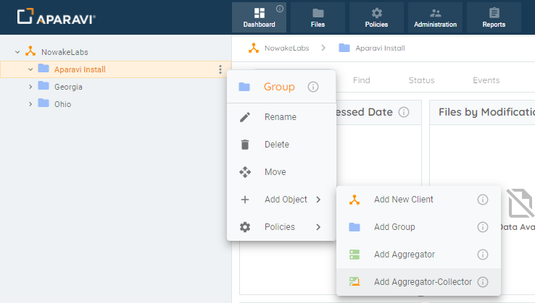Add Object

* Select **Add Aggregator-Collector**. The Add Aggregator-Collector modal will appear. At this point you can fill in the required information.
  + **Aggregator-Collector Name** – the name for the aggregator within the Aparavi portal
  + **Platform** – Windows or Linux
  + **Connect To** – auto populated with Aparavi portal URL
  + **App Program Folder** – location for the install (Windows only)
  + **App Data Folder** – location for the user data
  + **DB Host** – MySQL host IP, local by default
  + **DB Port**– 3306 default
  + **DB User**– the designated user for MySQL DB
  + **DB Password**– password for the MySQL DB user
  + **Use Redis Keystore** – leave unchecked to use the built-in keystore, or check to use the Redis keystore if that is installed and preferred

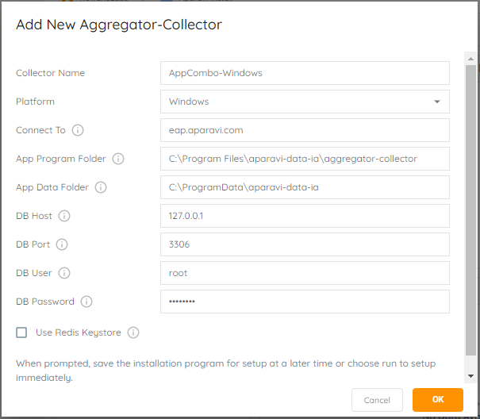Add New Aggregator-Collector (Windows)

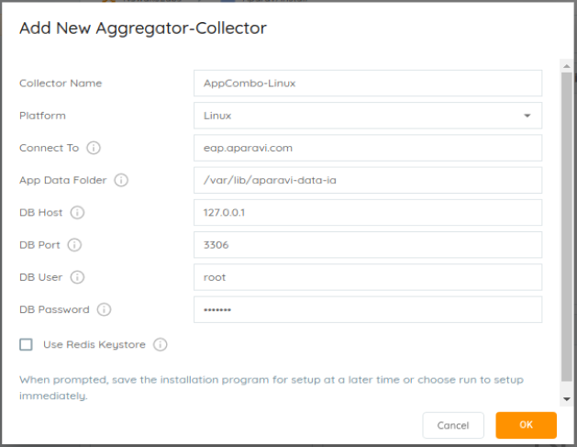Add New Aggregator-Collector (Linux)

* Select the OK button once all required information has been entered. This will initiate the Aggregator-Collector installer download locally.  If you are not accessing the portal on the server where the Aggregator-Collector installation will occur, the downloaded installation file will need to be copied over to the server designated above before proceeding.

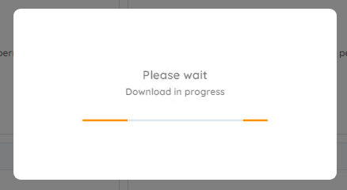Download in progress

**Windows installs**

* Launch the installer to proceed with the Aggregator-Collector installation. The installer will extract, and the installation is completely automated.

Ein Bild, das Text enthält.
Aggregator-Collector installing (Windows)

**Linux installs**

* When download completes, select the option to **save** the downloaded file, which will place the file in the current user’s Download directory. Open a terminal and set the default location to the Download directory, in most cases using this command:

cd ~/Downloads

* The downloaded filename will include the Aggregator-Collector as named with the version number and a .run file extension. The file must be set executable in order to launch the installation. Using an example filename, here is the command to set the file executable:

chmod a+x install-AppCombo-Linux-1.4.0-5952.run

* The installation can now be started and must be run either while logged in a root or by using the sudo command. Here is an example of the latter case:

sudo ./install-AppCombo-Linux-1.4.0-5952.run

* The installation will run, showing progress during the process until complete, with no further user action needed, as shown

Ein Bild, das Text enthält.
Aggregator-Collector installing (Linux)

**Install complete**

* Once the installation is complete, the Aparavi Data IA Aggregator-Collector service will automatically start. Within the portal interface, the new deployed Aggregator-Collector will automatically come online and is now ready for service.

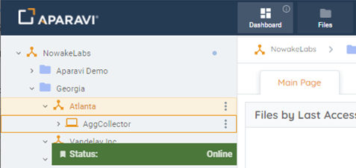Aggregator-Collector online